**PRACTICAL-15**

Aim: Write a prolog program to find the rules for parent, child, male, female, son, daughter, brother, sister, uncle, aunt, ancestor given the facts about father and wife only.

Description: PROLOG stands for PROgramming in LOGic and has a very important role in artificial intelligence. It expresses any objects in the form of relations which are described using facts and rules. In this program we derive the different blood relations among the family members, and some logics like male, female and parent are given as facts while the relations between these like mother, father, brother, sister are described using the rules.

Program:

female(pam).

female(liz).

female(pat).

female(ann).

male(jim).

male(bob).

male(tom).

male(peter).

parent(pam,bob).

parent(tom,bob).

parent(tom,liz).

parent(bob,ann).

parent(bob,pat).

parent(pat,jim).

parent(bob,peter).

parent(peter,jim).

mother(X,Y):- parent(X,Y),female(X).

father(X,Y):- parent(X,Y),male(X).

haschild(X):- parent(X,_).

sister(X,Y):- parent(Z,X),parent(Z,Y),female(X),X\==Y.

brother(X,Y):-parent(Z,X),parent(Z,Y),male(X),X\==Y.

Output:

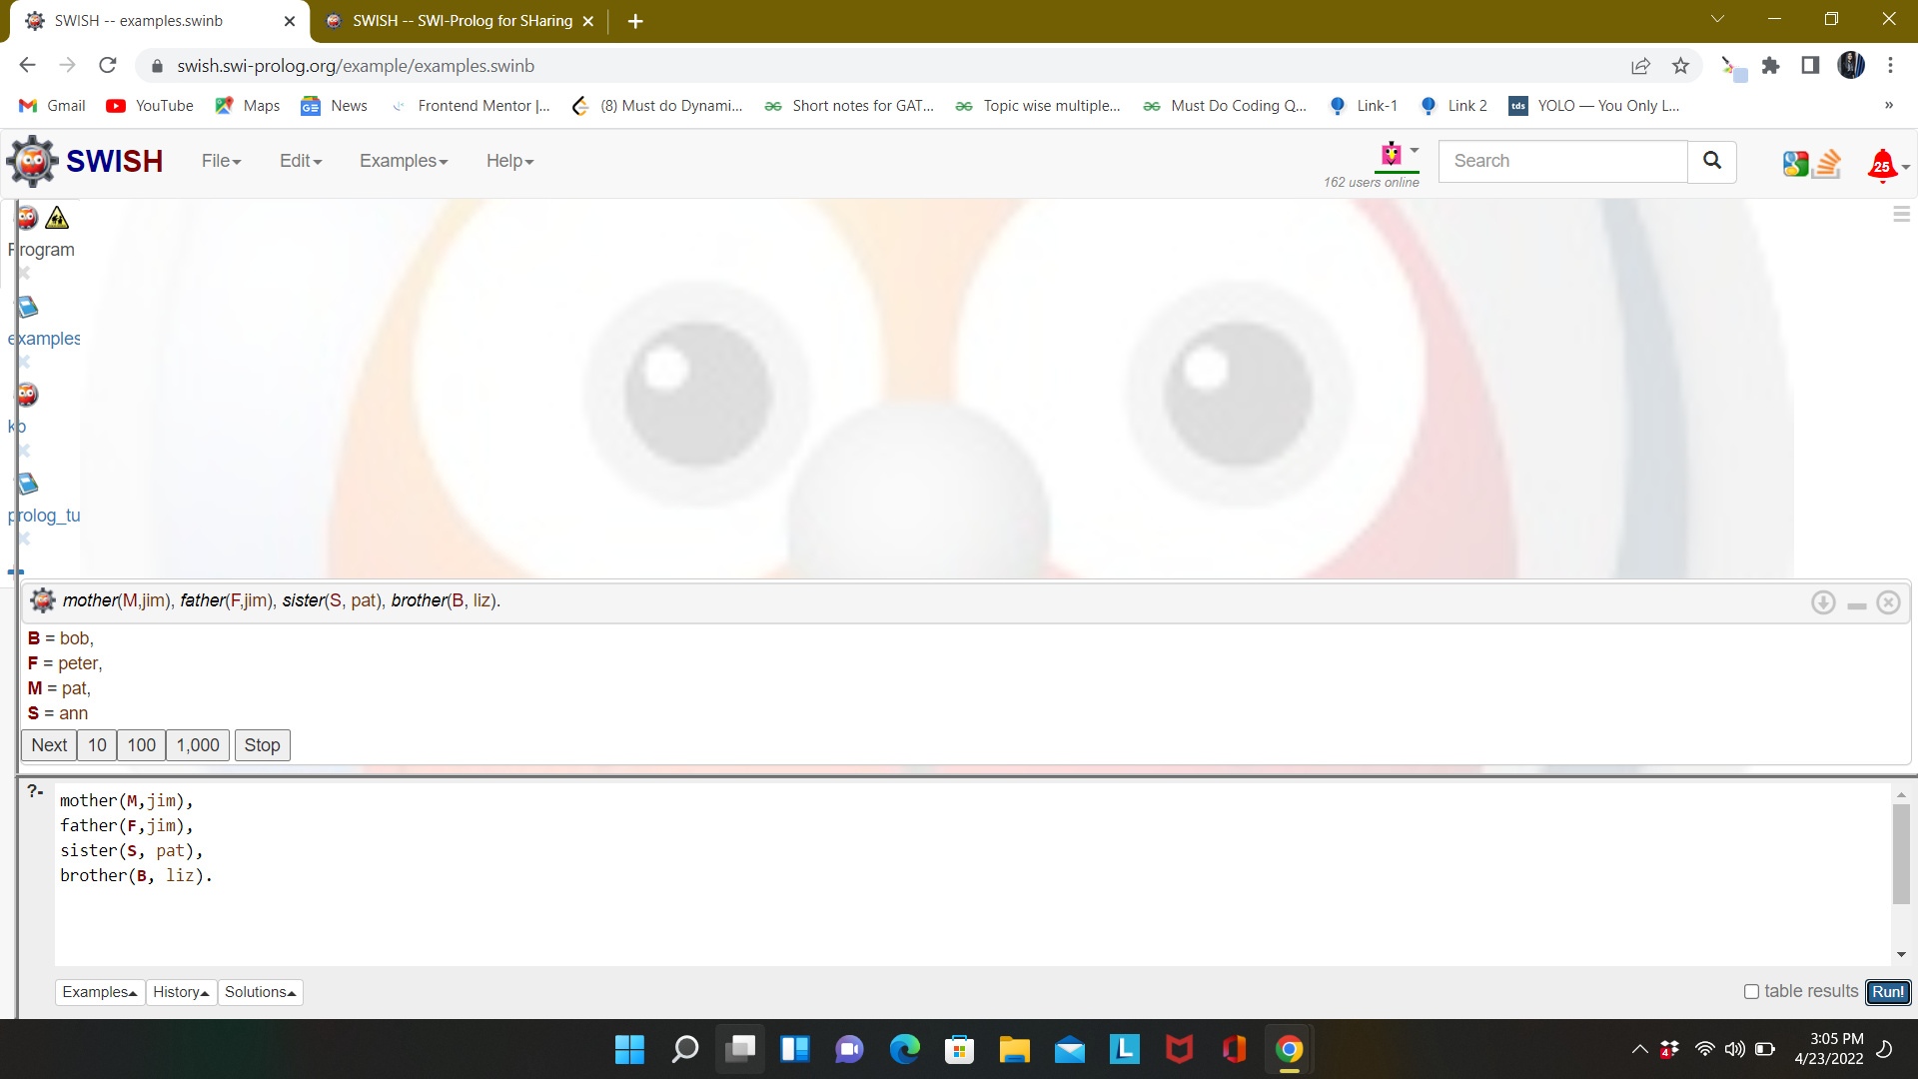

PROGRAM-22

Aim: Write a prolog program given the knowledge base, If Town x is connected to Town y by

highway z and bikes are allowed on z, you can get to y from x by bike. If Town x is

connected to y by z then y is also connected to x by z. If you can get to town q from p and

also to town r from town q, you can get to town r from town p.

a. Town A is connected to Town B by Road1.

b. Town B is connected to Town C by Road2.

c. Town A is connected to Town C by Road3.

d. Town D is connected to Town E by Road4.

e. Town D is connected to Town B by Road5.

f. Bikes are allowed on roads 3, 4, 5.

Bikes are only either allowed on Road1 or on Road2 every day. Convert the following

into WFF’s, clausal form and deduce that ‘One can get to town B from town D’.

Description: In this program, we express the given information as facts and then derive rules for conditions of connection, reachability and roads as given in the aim. After deriving the facts and the rules we check whether or not town B can be reached through town D; if the result comes out to be true, then it is reachable, else it is not.

Program:

connect(A,B,1).

connect(B,C,2).

connect(A,C,3).

connect(D,E,4).

connect(D,B,5).

connect(P,R,_):- connect(P,Q,_), connect(Q,R,_).

bikeallowed(3).

bikeallowed(4).

bikeallowed(5).

bikeallowed(1) :- not(bikeallowed(2)).

bikeallowed(2) :- not(bikeallowed(1)).

cango(X,Y,Z) :- (connect(X,Y,Z) ; connect(Y,X,Z)), bikeallowed(Z).

Output:

